1. Project overview
The Student Performance and Academic Record Management System is a console-based application designed to maintain student academic records. It allows a user to add students, display all records, search for a student by ID, and analyze class performance.
The program stores records in a file so that the data remains available after the application closes.

Objectives
Apply classes and objects to a real-world problem.
Implement inheritance and runtime polymorphism.
Use encapsulation to protect student information.
Calculate averages and grades automatically.
Implement file handling for permanent storage.
Analyze class performance using mean marks and pass statistics.

2.OOP concepts used

Concept | Implementation
Class and object | Person, Student, and individual student objects
Encapsulation | Private student details and marks
Inheritance | Student inherits from Person
Polymorphism | Virtual displayRecord() function
Abstraction | Students interact with a menu instead of internal file operations
File handling | Student records are stored in students.txt
Data analysis | Average marks, highest average and pass percentage

Features of the project
Add student record
Enter a student's ID, name and marks in five subjects.
Display all students
View marks, calculated averages, grades and pass/fail status.
Search student
Retrieve an individual record using its unique ID.
Performance analysis
Calculate class average, highest-performing student and pass percentage.
Permanent storage
Save records and load them automatically when the application starts.

4. Complete C++ source code
Create a file named student_management.cpp and copy the following program into it.

#include <iostream>
#include <fstream>
#include <sstream>
#include <vector>
#include <array>
#include <iomanip>
#include <string>
#include <limits>
using namespace std;

const int SUBJECTS = 5;
const string FILE_NAME = "students.txt";

// Base class
class Person {
private:
int id;
string name;

public:
Person(int studentId, string studentName)
: id(studentId), name(studentName) {}

int getId() const {
return id;
}

string getName() const {
return name;
}

virtual void displayRecord() const = 0;

virtual ~Person() {}
};

// Derived class
class Student : public Person {
private:
array<double, SUBJECTS> marks;

public:
Student(int id, string name,
array<double, SUBJECTS> studentMarks)
: Person(id, name), marks(studentMarks) {}

double calculateAverage() const {
double total = 0;

for (double mark : marks) {
total += mark;
}

return total / SUBJECTS;
}

bool isPassed() const {
for (double mark : marks) {
if (mark < 40)
return false;
}

return true;
}

string calculateGrade() const {
if (!isPassed()) return "F";

double avg = calculateAverage();

if (avg >= 80) return "A";
if (avg >= 70) return "B";
if (avg >= 60) return "C";
if (avg >= 50) return "D";
return "E";
}

array<double, SUBJECTS> getMarks() const {
return marks;
}

void displayRecord() const override {
cout << left << setw(8) << getId()
<< setw(22) << getName();

for (double mark : marks) {
cout << setw(9) << mark;
}

cout << setw(10) << fixed << setprecision(2)
<< calculateAverage()
<< setw(8) << calculateGrade()
<< (isPassed() ? "PASS" : "FAIL")
<< '\n';
}
};

// Load saved records from file
void loadRecords(vector<Student>& students) {
ifstream file(FILE_NAME);
string line;

while (getline(file, line)) {
stringstream ss(line);
string field;

int id;
string name;
array<double, SUBJECTS> marks{};

if (!getline(ss, field, '|'))
continue;

try {
size_t pos;
id = stoi(field, &pos);

if (pos != field.size())
continue;
} catch (...) {
continue;
}

if (!getline(ss, name, '|'))
continue;

bool valid = true;

for (int i = 0; i < SUBJECTS; i++) {
if (!getline(ss, field, '|')) {
valid = false;
break;
}

try {
size_t pos;
marks[i] = stod(field, &pos);

if (pos != field.size() ||
marks[i] < 0 || marks[i] > 100) {
valid = false;
break;
}
} catch (...) {
valid = false;
break;
}
}

if (!valid || id <= 0 || name.empty())
continue;

bool duplicate = false;

for (const Student& s : students) {
if (s.getId() == id) {
duplicate = true;
break;
}
}

if (!duplicate)
students.emplace_back(id, name, marks);
}
}

// Save one new student record
bool saveRecord(const Student& student) {
ofstream file(FILE_NAME, ios::app);

if (!file)
return false;

file << student.getId() << '|'
<< student.getName() << '|';

array<double, SUBJECTS> marks =
student.getMarks();

for (int i = 0; i < SUBJECTS; i++) {
file << marks[i] << '|';
}

file << '\n';
return static_cast<bool>(file);
}

bool idExists(const vector<Student>& students, int id) {
for (const Student& s : students) {
if (s.getId() == id)
return true;
}

return false;
}

// Add a student
void addStudent(vector<Student>& students) {
int id;
string name;
array<double, SUBJECTS> marks{};

cout << "\nEnter student ID: ";

if (!(cin >> id) || id <= 0) {
cout << "Invalid ID.\n";
cin.clear();
cin.ignore(numeric_limits<streamsize>::max(), '\n');
return;
}

cin.ignore(numeric_limits<streamsize>::max(), '\n');

if (idExists(students, id)) {
cout << "Student ID already exists.\n";
return;
}

cout << "Enter student name: ";
getline(cin, name);

if (name.empty() || name.find('|') != string::npos) {
cout << "Invalid name.\n";
return;
}

for (int i = 0; i < SUBJECTS; i++) {
cout << "Enter marks for subject "
<< i + 1 << " (0-100): ";

if (!(cin >> marks[i]) ||
marks[i] < 0 || marks[i] > 100) {
cout << "Invalid marks. Record not added.\n";
cin.clear();
cin.ignore(
numeric_limits<streamsize>::max(), '\n'
);
return;
}
}

cin.ignore(numeric_limits<streamsize>::max(), '\n');

Student student(id, name, marks);

if (!saveRecord(student)) {
cout << "Error: Unable to save record.\n";
return;
}

students.push_back(student);
cout << "Student record added successfully.\n";
}

// Display all records
void displayStudents(const vector<Student>& students) {
if (students.empty()) {
cout << "\nNo student records found.\n";
return;
}

cout << '\n' << left
<< setw(8) << "ID"
<< setw(22) << "Name";

for (int i = 1; i <= SUBJECTS; i++) {
cout << setw(9) << ("Sub" + to_string(i));
}

cout << setw(10) << "Average"
<< setw(8) << "Grade"
<< "Status\n";

cout << string(100, '-') << '\n';

// Runtime polymorphism
for (const Student& s : students) {
const Person* person = &s;
person->displayRecord();
}
}

// Search by ID
void searchStudent(const vector<Student>& students) {
int id;

cout << "Enter student ID to search: ";

if (!(cin >> id)) {
cout << "Invalid ID.\n";
cin.clear();
cin.ignore(numeric_limits<streamsize>::max(), '\n');
return;
}

cin.ignore(numeric_limits<streamsize>::max(), '\n');

for (const Student& s : students) {
if (s.getId() == id) {
cout << "\nStudent record found:\n";

cout << left << setw(8) << "ID"
<< setw(22) << "Name";

for (int i = 1; i <= SUBJECTS; i++)
cout << setw(9) << ("Sub" + to_string(i));

cout << setw(10) << "Average"
<< setw(8) << "Grade"
<< "Status\n";

s.displayRecord();
return;
}
}

cout << "Student not found.\n";
}

// Analyze class performance
void analyzePerformance(const vector<Student>& students) {
if (students.empty()) {
cout << "\nNo records available for analysis.\n";
return;
}

double totalAverage = 0;
int passed = 0;
int highestIndex = 0;

for (int i = 0; i < static_cast<int>(students.size()); i++) {
totalAverage += students[i].calculateAverage();

if (students[i].isPassed())
passed++;

if (students[i].calculateAverage() >
students[highestIndex].calculateAverage()) {
highestIndex = i;
}
}

cout << fixed << setprecision(2);
cout << "\n--- Class Performance Analysis ---\n";
cout << "Total students: " << students.size() << '\n';
cout << "Class average: "
<< totalAverage / students.size() << '\n';
cout << "Students passed: " << passed << '\n';
cout << "Students failed: " << students.size() - passed << '\n';
cout << "Pass percentage: "
<< (passed * 100.0 / students.size()) << "%\n";
cout << "Highest performer: "
<< students[highestIndex].getName()
<< " (ID: " << students[highestIndex].getId()
<< "), average: "
<< students[highestIndex].calculateAverage()
<< '\n';
}

int main() {
vector<Student> students;

loadRecords(students);

int choice;

do {
cout << "\n====================================\n";
cout << " STUDENT PERFORMANCE MANAGEMENT\n";
cout << "====================================\n";
cout << "1. Add Student Record\n";
cout << "2. Display All Students\n";
cout << "3. Search Student by ID\n";
cout << "4. Analyze Class Performance\n";
cout << "5. Exit\n";
cout << "Enter your choice: ";

if (!(cin >> choice)) {
cout << "Please enter a valid number.\n";
cin.clear();
cin.ignore(
numeric_limits<streamsize>::max(), '\n'
);
continue;
}

cin.ignore(numeric_limits<streamsize>::max(), '\n');

switch (choice) {
case 1:
addStudent(students);
break;

case 2:
displayStudents(students);
break;

case 3:
searchStudent(students);
break;

case 4:
analyzePerformance(students);
break;

case 5:
cout << "Thank you for using the system.\n";
break;

default:
cout << "Invalid choice. Try again.\n";
}

} while (choice != 5);

return 0;
}

5. How to run the project
You can run this project using Code::Blocks, Visual Studio Code with a C++ compiler, or an online C++ compiler.

Step 1: Create the source file
Save the code as student_management.cpp.

Step 2: Compile the program
If you have GCC installed, open a terminal in the file's folder and run:
g++ -std=c++17 student_management.cpp -o student_management

Step 3: Execute the program
On Windows:
student_management.exe
On Linux or macOS:
./student_management

Step 4: Check data storage
The program creates or updates students.txt in its working directory when records are added. Keep this file to retain your records.

6.output
The following is an illustrative test using sample student data.
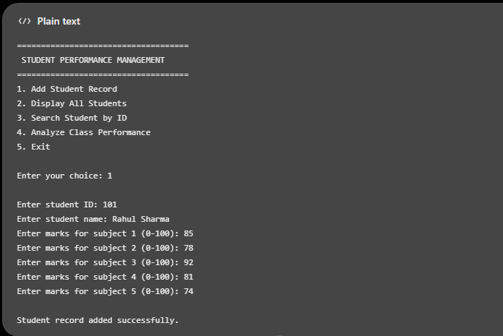
Selecting option 2 displays the stored records:
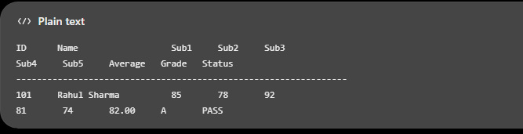
Selecting option 4 displays class statistics. For the single student above 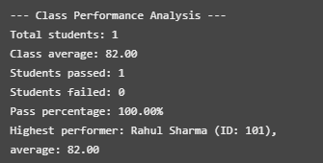

7. Explanation of the important code

A. Inheritance
class Student : public Person
The Student class inherits the ID and name-related functionality from Person. This reduces duplication and represents the relationship between a person and a student.

B. Encapsulation
private:
array<double, SUBJECTS> marks;
The marks are private, so other parts of the program cannot modify them directly. They can access them through the public getter function.

C. Polymorphism
virtual void displayRecord() const = 0;
This declares a pure virtual function in the base class. The derived Student class implements it.The statement person->displayRecord() calls the derived class implementation through a base-class pointer. This demonstrates runtime polymorphism.

D. Grade calculation
The system first checks whether the student passed every subject. A mark below 40 in any subject results in an overall fail. Otherwise, the grade is calculated from the average.
Average marks | Grade
80–100 | A
70–79.99 | B
60–69.99 | C
50–59.99 | D
40–49.99 | E
Any subject below 40 | F
These are the project's sample grading rules, not an official university grading policy.

E. File handling
The program uses ifstream to load records and ofstream with ios::app to append new records. This allows data to remain stored between executions.
The current version supports adding, displaying, searching and analyzing records. Editing and deleting existing records are not included.

8. Testing and validation
Test case | Expected result
Add a student with valid marks | Record saved successfully
Enter a duplicate student ID | Duplicate rejected
Enter marks greater than 100 | Invalid record rejected
Search using an existing ID | Correct record displayed
Search using a nonexistent ID | Student not found
Analyze with no student records | Informative message displayed
Restart the application | Previously saved records loaded

9. Limitations and future scope
The application is designed as a medium-level academic project rather than a full college administration system.
Possible improvements include:

Editing and deleting student records.
Generating individual student report cards.
Adding subject names instead of generic subject numbers.
Exporting performance summaries to CSV for analysis in Excel or Python.
Adding login authentication and role-based access.
Creating a graphical user interface and a database-backed version.

10. Conclusion

The Student Performance and Academic Record Management System demonstrates how object-oriented programming can be used to solve an academic record-management problem. It combines inheritance, encapsulation, abstraction, polymorphism, file handling and basic statistical analysis in one application.

